**MINOR PROJECT**

**REPORT**

**For**

**Stronghold Analytics**

Submitted By

|  |  |  |  |
| --- | --- | --- | --- |
| **NAME** | **SAP ID** | **ROLL NO** | **SPECIALIZATION** |
| Munendra Yaduvanshi | 500106531 | R252222136 | AIML |
| Aviral Birthare | 500110037 | R252222132 | AIML |
| Harsh Sharma | 500110172 | R252222137 | AIML |
| A.Teja | 500112513 | R252222158 | AIML |



**SCHOOL OF COMPUTER SCIENCE**

UNIVERSITY OF PETROLEUM AND ENERGY STUDIES

DEHRADUN-248007 UTTARAKHAND

Dr.Roohi Sille Dr. Anil Kumar

**Project Guide Cluster Head**

**Prof. Sanjeev Kumar**

**Submitted To**

**Table of Contents**

|  |  |
| --- | --- |
| **TOPIC** | **PAGE NO** |
| Project Title | 4 |
| Abstract | 4 |
| Introduction | 5 |
| Problem Statement | 6 |
| Objectives | 6 |
| Methodology | 6,7 |
| UML diagram | 8 |
| Manual guide | 9 |
| Screenshot & Results | 10-12 |
| References | 13 |



1. **Project Title**Stronghold Analysis.
2. **Abstract**Stock analysis is very important in planning business activities or taking personal financial decisions about investing. A thorough Stock analysis can maximize your profits and reduce your loss percentage. The prediction of stock price has driven many researches in many fields, including computer science, statistics, economics, finance, etc. Recent studies have shown that the enormous amount of online information that is available in the public domain, such as Wikipedia, the social forums, news from media, have a significant impact on the investor’s opinion towards the financial markets. The reliability of the computational models on prediction of the stock market is very important, because it is highly responsive to the economy and may result in financial losses. In this minor project we are going to do extensive and thorough research on various stocks available in the international market. We are going to predict the trends in stocks and visualize it in our website called “Stronghold”. The name itself strongly upheld for prediction.

Keywords: - Stocks, stocks analysis, stronghold, Stock predictions.

**3.Introduction**

Forecasting of stock market is a long time attractive topic for researchers and investors and it is a way to predict future prices of stocks. The stock prices are dynamic they change day by day and sometimes stocks prices even changes in hours so it becomes very difficult for the investors to decide at which time they should buy or sell a stock or multiple stocks. The trend in a stock market prediction is not a new thing but it is a big issue which is discussed by various organizations and individual investors also.

There are two ways to analyze stocks :   
one is the fundamental analysis, in this method the investors look at the intrinsic value of stocks, economy of the country, performance of the company, etc. to decide whether to invest or not.

The other stock analysis method is the technical analysis,  
In this method the analysis is done by studying the statistics generated by market activity, for example past prices, volumes, etc. This method is popular and is used more by businesses and individuals nowadays. In the recent years, due to the rise of machine learning techniques in various industries has inspired many investors to use data science and machine learning in the field of stock market and it has also shown some good results.

Machine learning provides a wide range of algorithms to perform stock analysis. In this project we are going to use some of these Data mining algorithms to forecast stock prices for some companies present in the International stock market. Our main goal is to analyze and predict the stock prices using python and visualize it on our website “Stronghold”.  
To achieve more accuracy and relevant forecasting we will be pre-processing the historical datasets of stocks indexes used in the project. The main purpose of the prediction is to reduce uncertainty associated with investment decision making.

**4.Problem Statement**

One of the main issues faced by business and individual investors is confusing decision making as there is a loads and loads of information available which makes it difficult for them invest and divert them from their main goal i.e. to make profits.

In this project(Stronghold) we are going to try to solve this problem by building an easy to use stock prices prediction tool for selected stocks present in International market.

**5.Objectives**

The project aims to introduce and democratize the latest machine learning technologies for retail investors. No prediction is 100% accurate. Therefore, the upper bound and lower bound of the stock prices will be displayed to illustrate the trading range the investors should be looking at. This application serves as a supplementary quantitative tool for investors to see the market at a different perspective with the help of technology. This project is divided into 2 parts, firstly search component and another is application component, aiming to provide investors with stock price predictions using different machine learning models and data science or data analytic in a good user experience way for reference.

**6.Methodology**

> Data acquisition-firstly we are going to extract or collect historical International stock market datasets from legit and reliable sources like kaggle, yahoo finance, alpha vantage, etc.

>Data preprocessing-  
we will perform data preprocessing steps to handle missing values, outliers, duplicate data and make sure the data is accurate and consistent.

We will use tools like python and python libraries like numpy, pandas,Sklearn for min max

>feature engineering-

Creating informative features from raw stock prices data to enhance performance.

Some features includes moving averages, relative strength index, dividend yield, etc.

We will use tools like python and python libraries like TA-lib for technical analysis.

>Model selection and training-

We will explore and evaluate various statistical models and some machine learning models to predict stock prices or classify market trends.

We are going to use algorithms like LSTM for simple trend prediction, random forests for non linear relationships, etc.

Tools we are going to use are python libraries like Scikit learn, tenserflow.

>Model evaluation and validation-  
Assess the performance of trained models and ensure their reliability and generalization to unseen data.

Evaluate model performance using appropriate metrics such as Mean Absolute Error (MAE), Mean Squared Error (MSE), or accuracy scores.

Tools we will use are pyhton libraries like scikit learn.

>Visualization-  
We will derive actionable insights from the analysis results and communicate findings effectively through visualization.

Visualize findings, trends, and predictions using a variety of charts and graphs, such as line plots, scatter plots, and histograms.

We will use matplotlib for the visualization of the data.

>Documentation-

We will document everything we will do in our minor project.

We will use softwares like ms office, ms powerpoint for documentaion.

**7.Block Diagram**

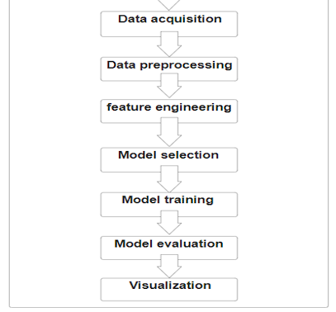

**9. Manual guide to run Stock analyzer**

The Manual guide to run this stock analyser is easy user need the particular specific requirement: - Windows 11, github clone, vscode, all python modules pre-installed. Below is the image for guidance however on the website there is a section of manual guide how stock analyzer works

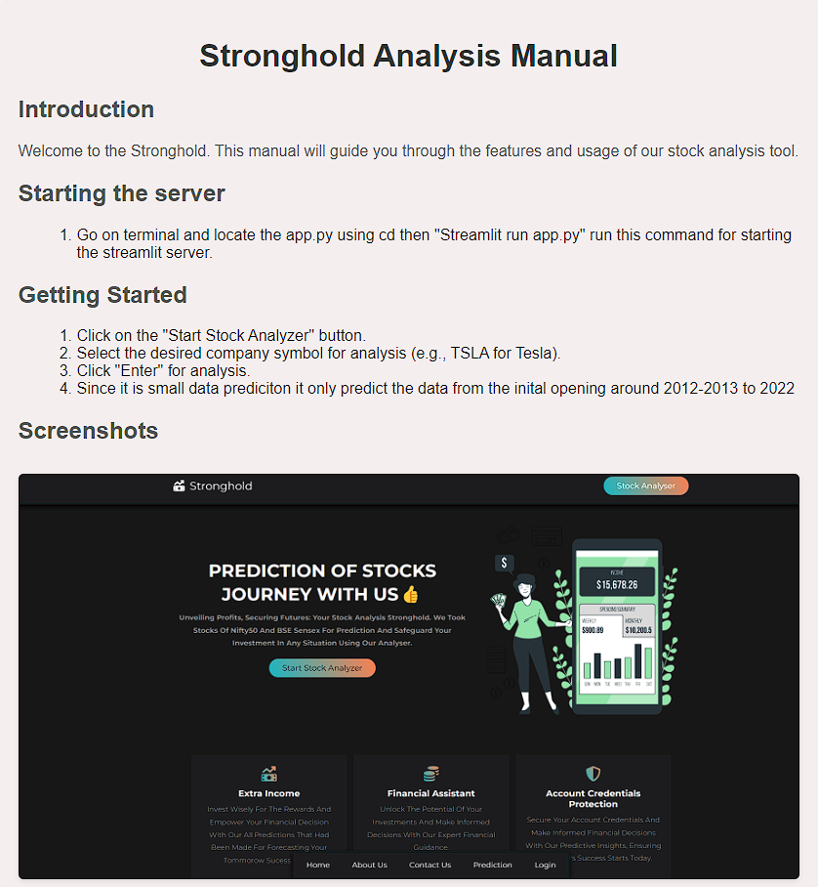

**10.Screenshot of final output and results**

Step 1: Opening of website

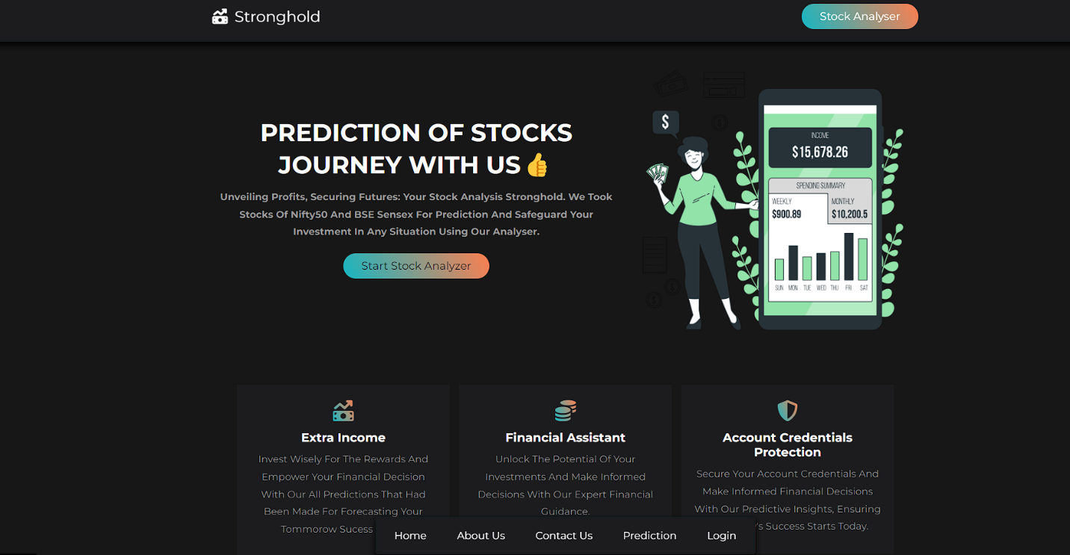

Step 2: Navigate to the Start Stock Analyzer on middle or top left 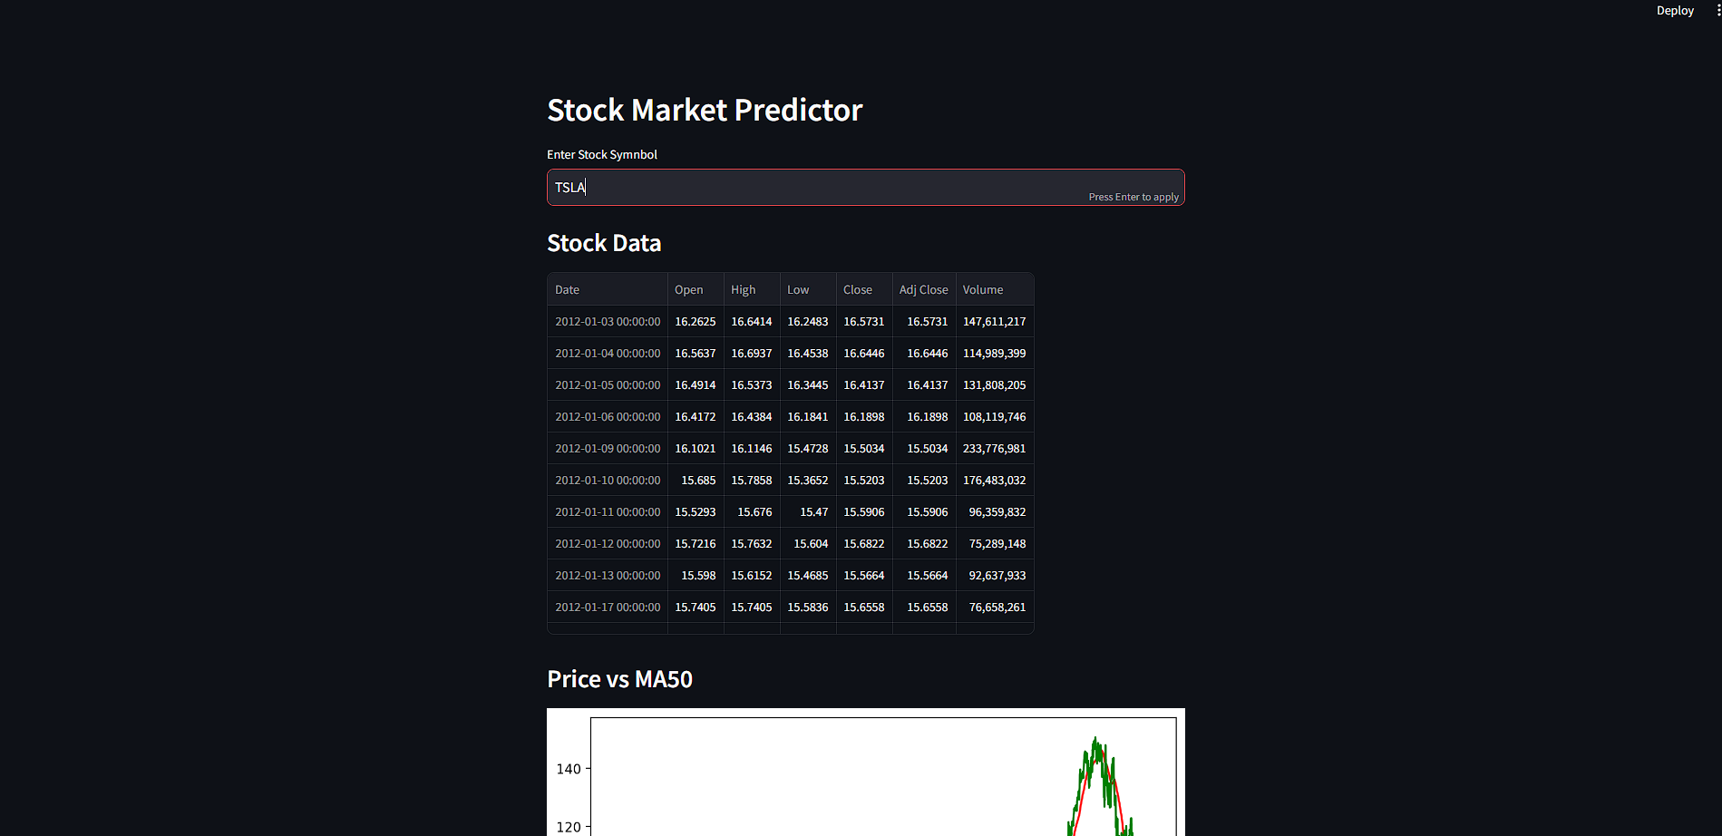

Step 3: Open yfinance on new tab and copy the alias of any company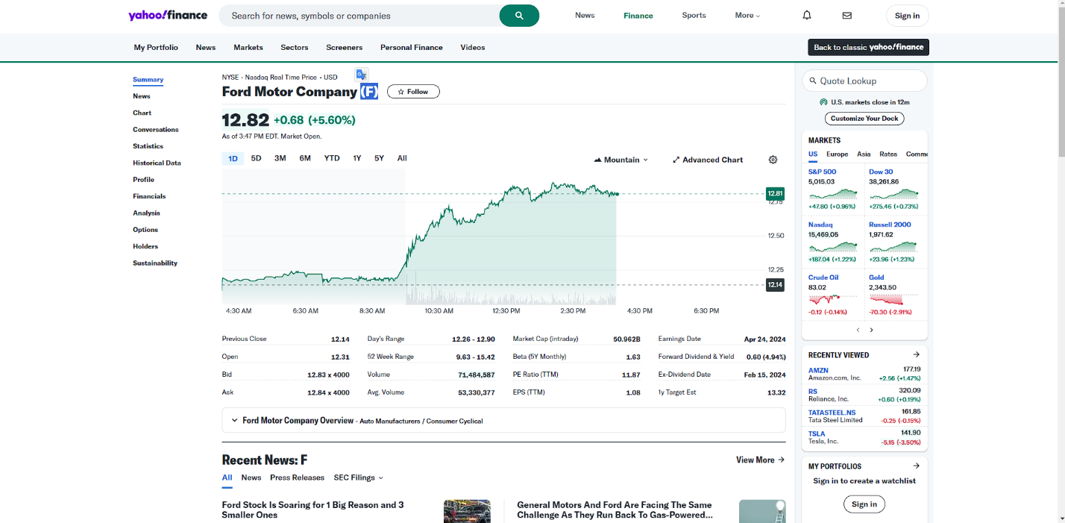

Step 4: Enter the alias in section and press enter 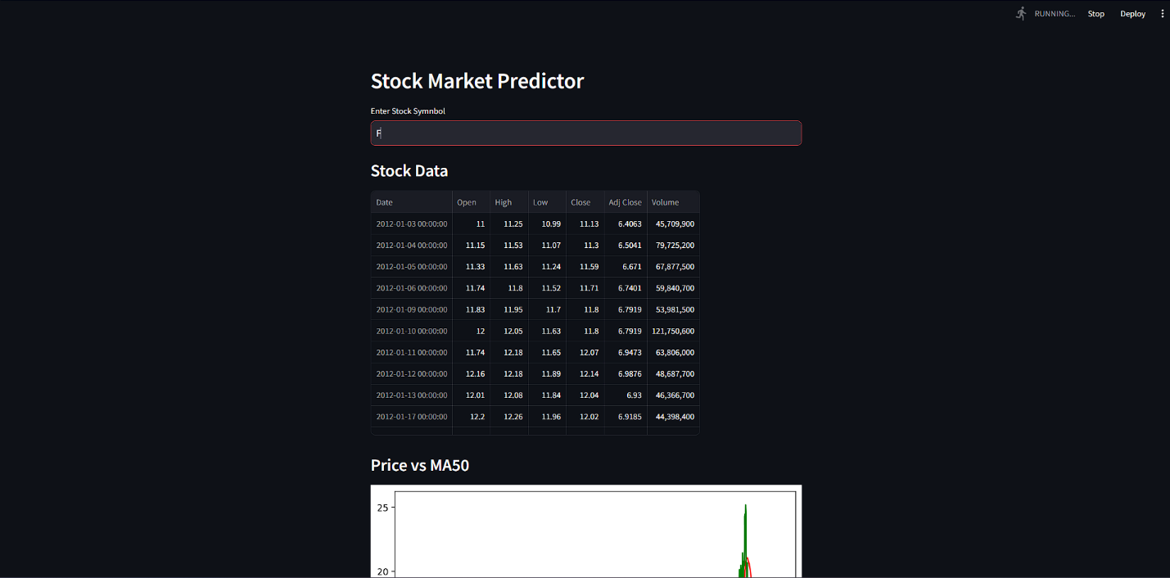

Step 5: Output presented in the graph.

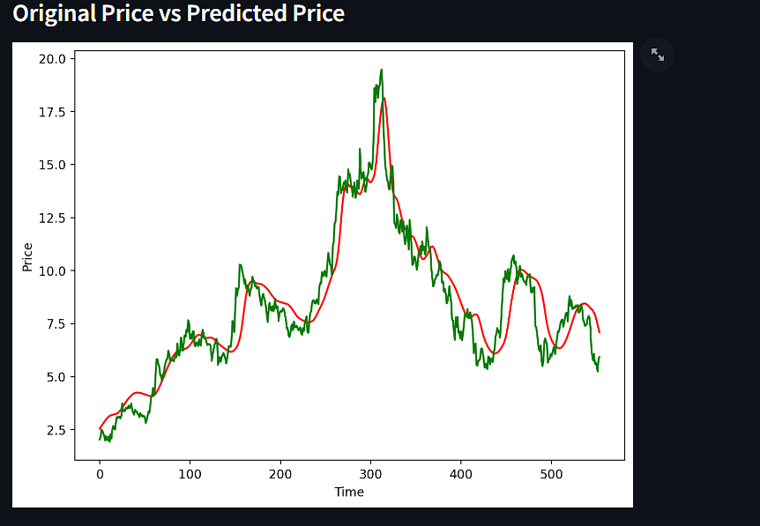

**11.References**

**(1)** Google

1. Youtube
2. Yahoo Finance
3. Google scholars.
4. ChatGPT, Gemini, github copilot
5. <https://www.studocu.com/> (stock analysis research papers).
6. <https://youtu.be/P3JlMWoP3fE?si=8jTaMo0e0jMSjtQn> For end to end application and deployment on the streamlit platform
7. <https://youtu.be/8F4MEluaG8g?si=gNztKSu6S7CKG7dR> The particular website that was kept in mind while creating and taking reference for website.